Software engineering for big data analaysis

CSA-1035

EXP NO: 1

1. Draw a use case diagram to model for Online Voting System. A web-based voting system that will help to manage elections easily and securely, the voter should be able to successfully cast his vote or it should be a failure. There should be no intermediate state. In case of failures the voter should be allowed to retry immediately. The voting data should be consistent throughout the system. If we are replicating the data, we do not want any scenario where one database shows Voter-1 has voted Candidate-1 and another database has an old entry for Voter-1 showing he has voted for Candidate-2. We should always have strong consistency

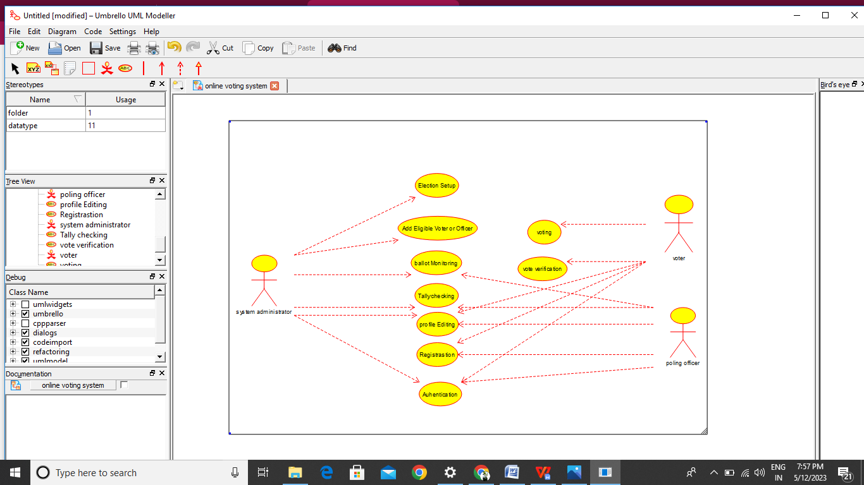

RESULT:-

Thus the use-case diagram for online voting system is drawn and verified successfully.